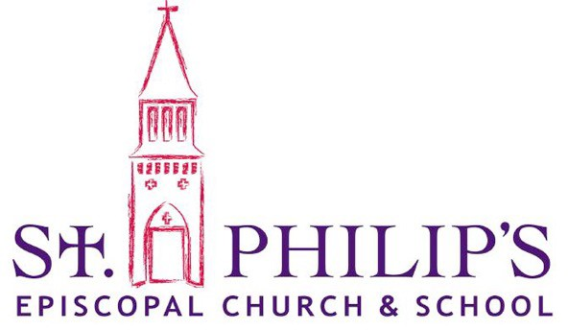
Head of School Search

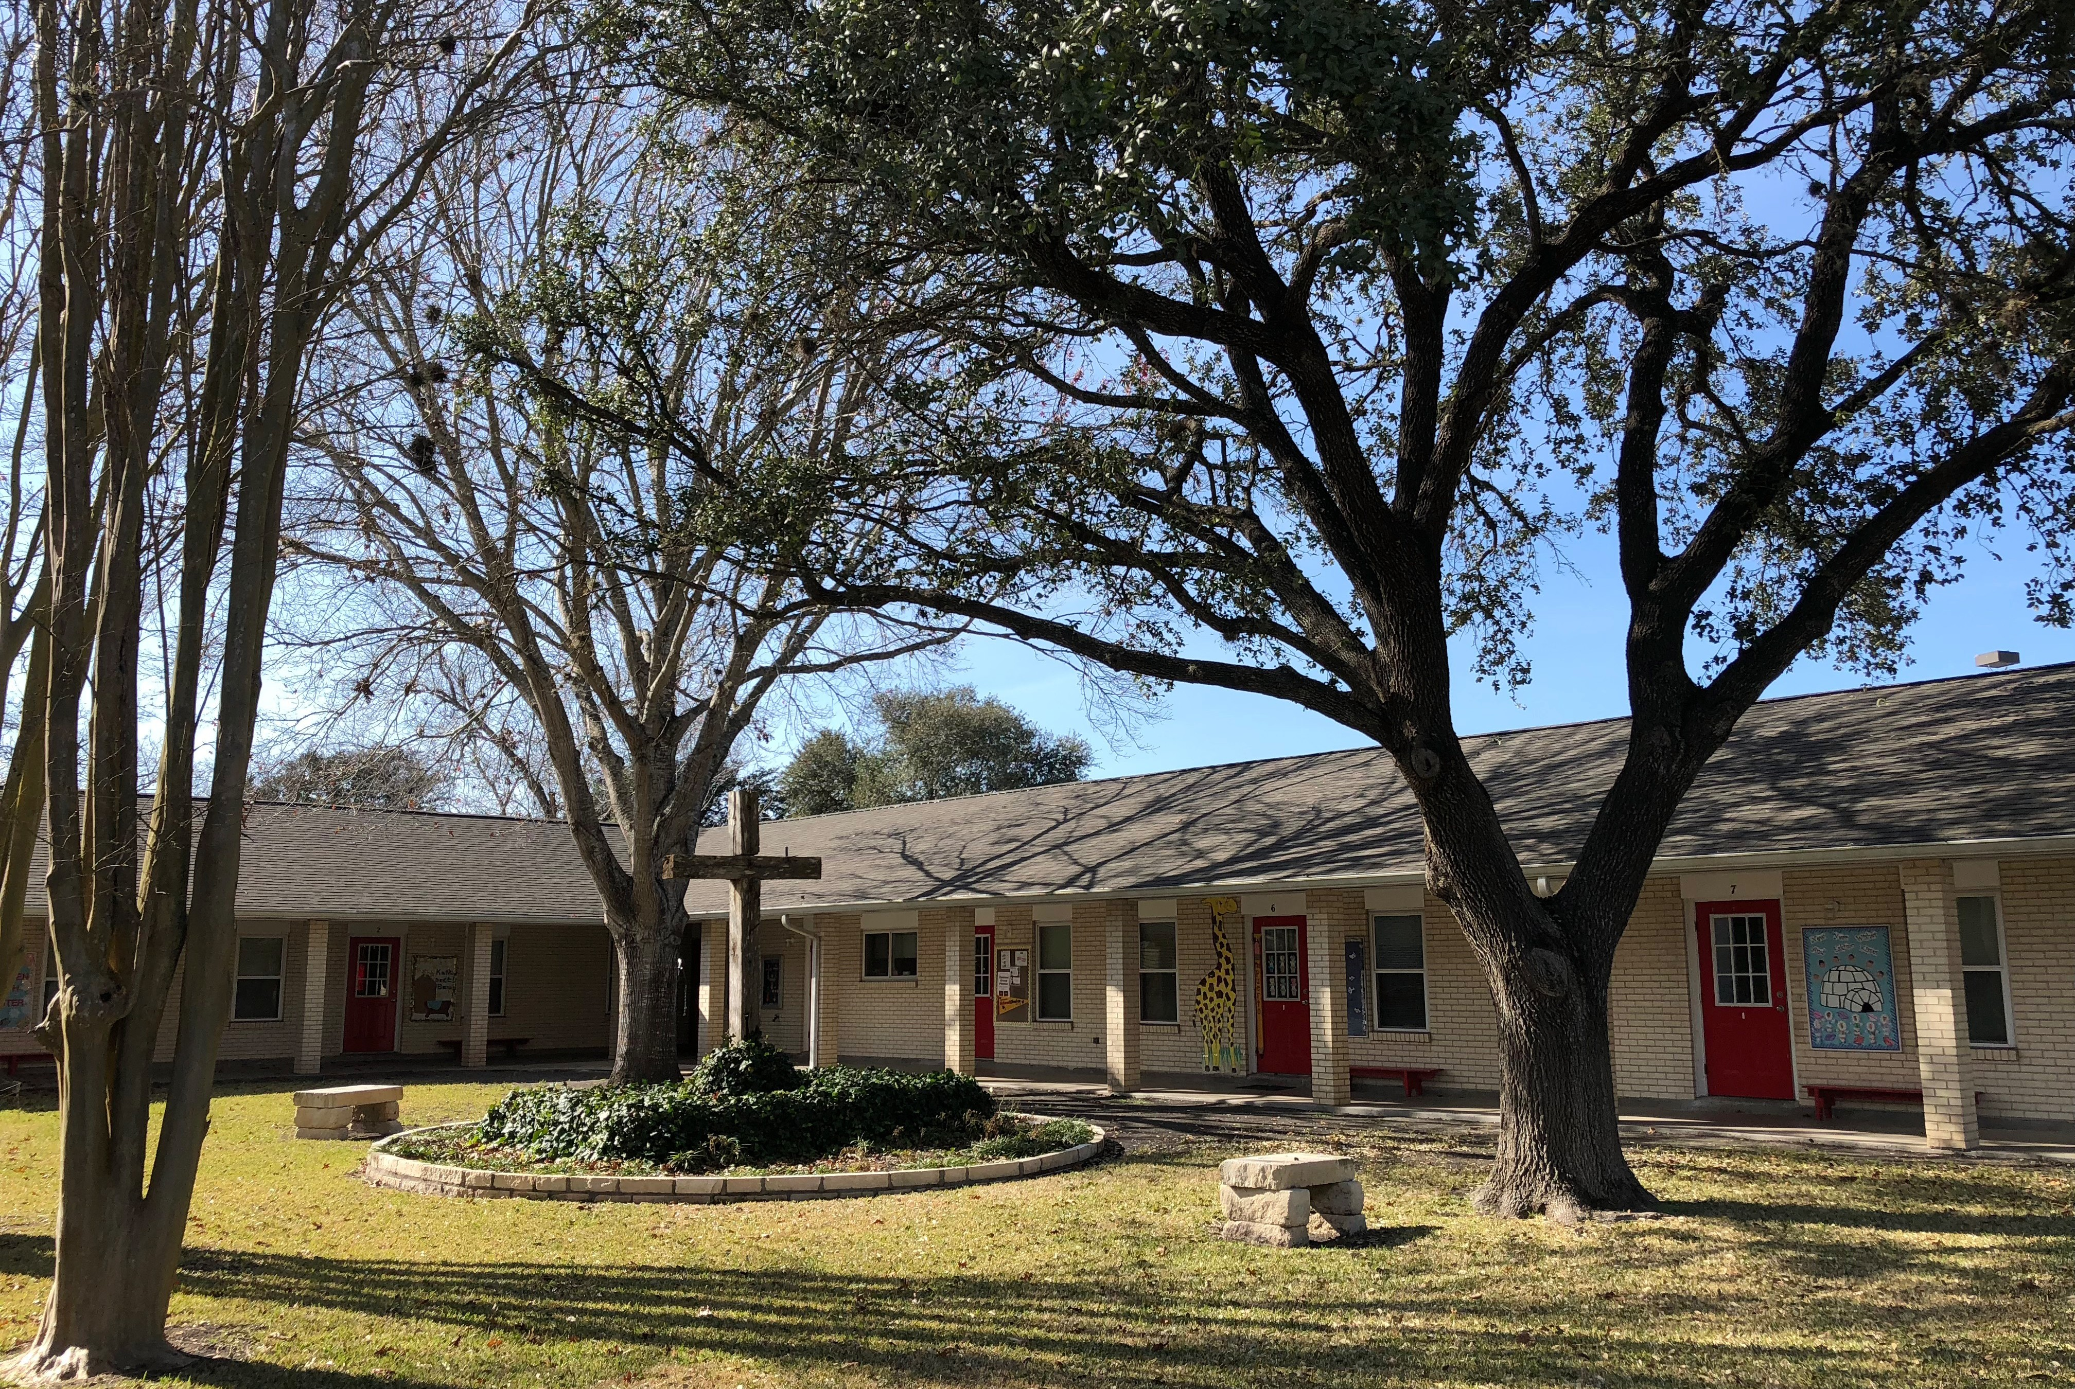

Mission Statement

St. Philip’s Episcopal School seeks to foster growth in academics, character, and spiritual morality through a challenging academic environment & nurturing Christian atmosphere.

St. Philip’s Episcopal School

St. Philip’s School is currently seeking a Head of School to begin at the conclusion of the current academic year ( June 1, 2018). The application deadline is on March 15, 2018.

St. Philip’s at a glance:
- Average Enrollment
- Serving children 3 year olds to 6th grade
- 21 classrooms
- 23 staff members including 17 teachers
- Regular School Hours 8:00 am - 3:30 pm
- Includes Music, Spanish, Computer, and Art
- Website: www.spepiscopalschool.org

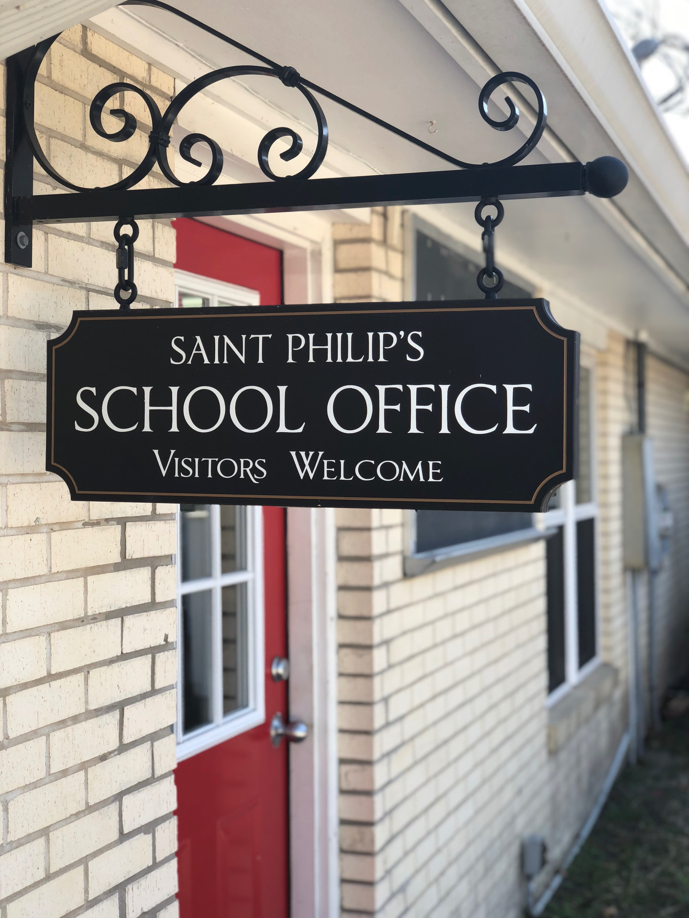
School Identity

Looking toward the 2018-19 academic year, St. Philip’s Episcopal School of Beeville will be entering it’s 64th year of excellence. From its humble beginnings as a one-room school house, St. Philip’s has grown to become an academic leader in the community. Presently, St. Philip's has two preschool classes, two pre- kinder classes, one Pre-k to Kinder transitional class, one kindergarten class, one first grade class, two second grade classes and one
each: third, fourth and fifth combined, and sixth grade classes. In addition, an extended care session is offered for parents who need after school care for their children. Early morning drop-off is also available.

St. Philip’s is proud of our curriculum that challenges students above and beyond normal standards in elementary education. Our students successfully integrate reading, Spanish, mathematics, and citizenship beginning in Kindergarten. We believe that students can achieve more than public standards expect. Through numerous foundations, endowments and fundraising, St. Philip’s has recently focused on reinforcing our strong curriculum through the utilization of modern technology and science.
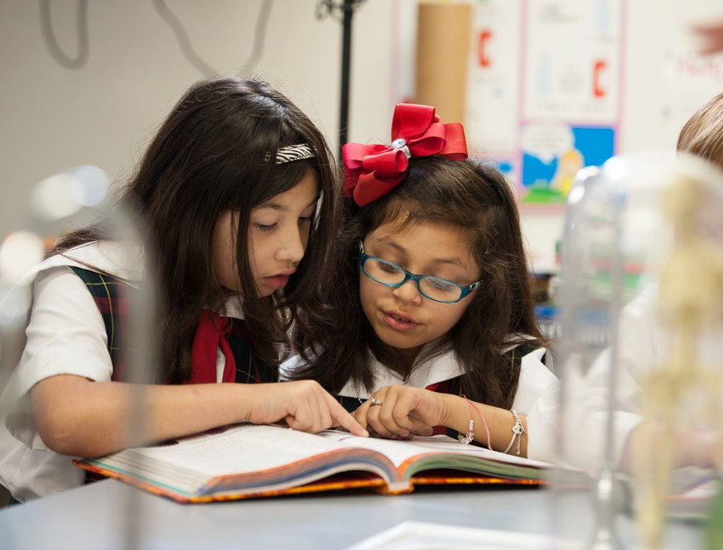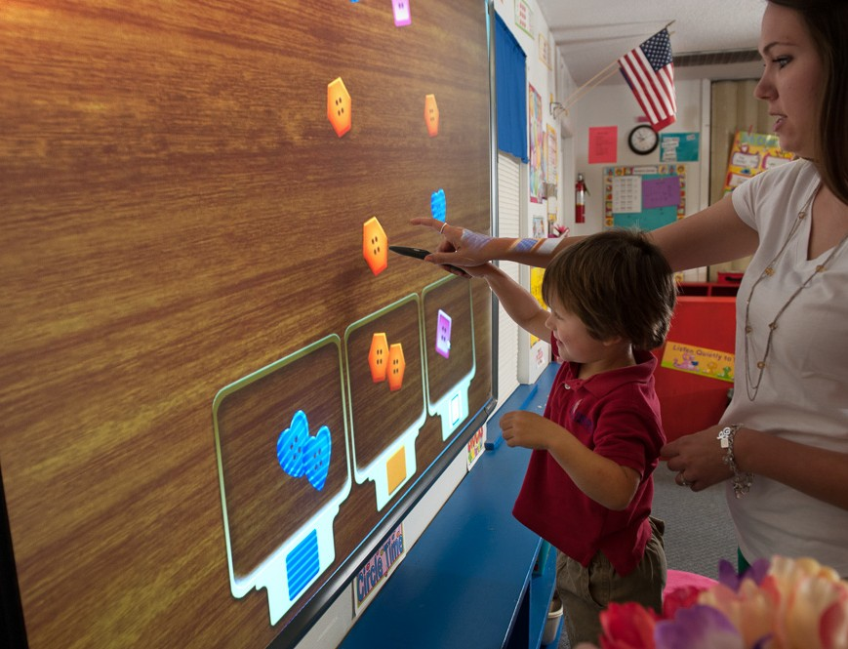

Central to our mission as an Episcopal school, we foster our student’s spiritual formation through daily chapel services and classroom lessons on moral decision- making. Our parents, staff, and students follow through on our calling as Christians by donating resources to others in need around the world.
Our alumni and leadership have gone on to serve the community, state, and our country in ways that carry forth the mission of our school. As a testament to our educational and spiritual formation, the valedictorians and salutatorians of the surrounding school districts, typically have their roots at St. Philip’s.

Vision for the Future
To provide an even more well-rounded education to our students, we plan to strengthen our current curriculum subjects and broaden students’ exposure to art, music, and athletics. By interacting with a wider variety of subject material, we wish to instill in our students a natural curiosity in the world around us.
The School Board also seeks to grow in strength in leadership, both internally and externally. Internally, we seek a Head of School who understands the school’s current position, future vision, and leads our staff to reach that vision. Externally, we seek to become an even stronger leader in the educational community.

Qualifications
Background and Educational Experience
- Minimum of 3-5 years classroom experience; elementary level education preferred
- Bachelor’s degree minimum requirement; Master’s degree or higher preferred; Degree specialty in education, education administration or business administration preferred
- An understanding of the operations and mission of a private school Administrative and Business Leadership Experience
- Three years or more of management and leadership experience
- Excellent written and verbal communication skills
- A community orientation and experience working with multiple stakeholders Finance and Development Experience
- Have a solid track record in sound fiscal operations, financial sustainability, school advancement
- Experience in development and grant writing preferred School Recruitment and Growth
- Experience implementing programs for growth or retention
- Experience with social media management and general marketing practices. Other
- Compatibility with the spiritual life of the church and school
- Understand the basic tenets of the Episcopal faith and identity

Responsibilities
Student and School
- In cooperation with the School Board, work toward fulfilling the school’s long-term vision
- Foster a sense of partnership between the church and school
- Lead faculty and staff in continuing professional development
- Grow school enrollment to maximum capacity over several years
- Improve student retention through upper-level grades
- Report to the school board at monthly meetings Finance and Operations
- Oversee staff including financial office managers
- Oversee day-to-day management of school operations
- Oversee day-to-day management of school budget
- Implement tactics in development either through fundraising or grant writing
- Experience with educational social media management and general marketing practices to grow awareness of the school, its mission, and school events
Curriculum and Spiritual Formation
- Maintain and enhance an age-appropriate curriculum that challenges students and prepares them for academic success in the long-term
- Identify curricular areas needing strengthening and execute remedies
- Lead staff in incorporating lessons of morality and faith in daily classroom lessons
- In cooperation with the Rector, plan and assist in leading daily chapel
- Establish annual academic goals that surpass the standards of both the state and local pre-school/elementary school competitors
- Annually review school performance against local and national statistics; Review school performance to evaluate accomplishments of internal goals.

Application
Submit the following by email to St. Philip’s Episcopal School Board Chairman, John Blackburn at headsearchstp@gmail.com.
- Letter of intent
- Current CV or resume
- Statement of educational philosophy
- Statement of personal faith
- List of 3-4 references with name, title, email and phone number. At least one reference must be from the educational field.
Please submit all materials no later than March 15, 2018. Contact the above email with any questions prior to submitting your application.

